

# 

### Semester Two Examination, 2020

### Question/Answer booklet

# MATHEMATICS

**SOLUTIONS**

**METHODS**

**UNITS 3&4**

## Section Two:

## Calculator-assumed

|  |  |  |  |  |  |  |  |  |  |  |
| --- | --- | --- | --- | --- | --- | --- | --- | --- | --- | --- |
| WA student number: In figures |  |  |  |  |  |  |  |  |  |  |

In words

Your name

|  |  |
| --- | --- |
| Number of additional answer booklets used (if applicable): |  |

## Time allowed for this section

Reading time before commencing work: ten minutes

Working time: one hundred minutes

## Materials required/recommended for this section

***To be provided by the supervisor***

This Question/Answer booklet

Formula sheet (retained from Section One)

***To be provided by the candidate***

Standard items: pens (blue/black preferred), pencils (including coloured), sharpener,  
correction fluid/tape, eraser, ruler, highlighters

Special items: drawing instruments, templates, notes on two unfolded sheets of A4 paper, and up to three calculators approved for use in this examination

## Important note to candidates

No other items may be taken into the examination room. It is **your** responsibility to ensure that you do not have any unauthorised material. If you have any unauthorised material with you, hand it to the supervisor **before** reading any further.

## Structure of this paper

|  |  |  |  |  |  |
| --- | --- | --- | --- | --- | --- |
| Section | Number of questions available | Number of questions to be answered | Working time (minutes) | Marks available | Percentage of examination |
| Section One: Calculator-free | 8 | 8 | 50 | 52 | 35 |
| Section Two: Calculator-assumed | 13 | 13 | 100 | 98 | 65 |
|  | | |  | **Total** | 100 |

## Instructions to candidates

1. The rules for the conduct of examinations are detailed in the school handbook. Sitting this examination implies that you agree to abide by these rules.

2. Write your answers in this Question/Answer booklet preferably using a blue/black pen.  
Do not use erasable or gel pens.

3. You must be careful to confine your answers to the specific question asked and to follow any instructions that are specific to a particular question.

4. Show all your working clearly. Your working should be in sufficient detail to allow your answers to be checked readily and for marks to be awarded for reasoning. Incorrect answers given without supporting reasoning cannot be allocated any marks. For any question or part question worth more than two marks, valid working or justification is required to receive full marks. If you repeat any question, ensure that you cancel the answer you do not wish to have marked.

5. It is recommended that you do not use pencil, except in diagrams.

6. Supplementary pages for planning/continuing your answers to questions are provided at the end of this Question/Answer booklet. If you use these pages to continue an answer, indicate at the original answer where the answer is continued, i.e. give the page number.

7. The Formula sheet is not to be handed in with your Question/Answer booklet.

Section Two: Calculator-assumed 65% (98 Marks)

This section has**thirteen** questions. Answer **all** questions. Write your answers in the spaces provided.

Working time: 100 minutes.

Question 9 (7 marks)

The percentage distribution of the number of cans of soft drink per order placed with a takeaway food company over a long period of time are shown in the following table.

|  |  |  |  |  |  |
| --- | --- | --- | --- | --- | --- |
| Number of cans per order | $$0$$ | $$1$$ | $$2$$ | $$3$$ | $4$ or more |
| Percentage of orders | $$14$$ | $$24$$ | $$45$$ | $$5$$ | $$12$$ |

In the following questions, you may assume that all orders are placed with the company at random and independently.

(a) Determine the probability that the next $10$ orders all include at least one can of soft drink.

(2 marks)

|  |
| --- |
| **Solution** |
| $$P\left(X≥1\right)=1-0.14=0.86$$ $$p={0.86}^{10}=0.2213$$ |
| **Specific behaviours** |
| ✓ probability of at least one can in one order  ü correct probability |

(b) During a weekday, a total of $225$ orders were placed. Determine the probability that

(i) $40$ of these orders included $3$ or more cans of soft drink. (3 marks)

|  |
| --- |
| **Solution** |
| $$X\sim B\left(225, 0.17\right)$$ $$P\left(X=40\right)=0.0662$$ |
| **Specific behaviours** |
| ✓ states binomial distribution, $n=225$ ü correct $p$ for distribution  ü correct probability |

(ii) more than $25$ of these orders included no cans of soft drink. (2 marks)

|  |
| --- |
| **Solution** |
| $$X\sim B\left(225, 0.14\right)$$ $$P\left(X≥26\right)=0.8774$$ |
| **Specific behaviours** |
| ✓ states binomial distribution with parameters  ü correct probability |

Question 10 (6 marks)

(a) Function $f$ is defined by $f\left(x\right)=5\log_{3}{(x+9)}-4$ over its natural domain. Determine

(i) the value of the $y$-intercept of the graph of $y=f(x)$. (1 mark)

|  |
| --- |
| **Solution** |
| $$f\left(0\right)=5\log_{3}{3^{2}}-4=5×2-4=6$$ |
| **Specific behaviours** |
| ✓ correct value |

(ii) the equation of the asymptote of the graph of $y=f(x)$. (1 mark)

|  |
| --- |
| **Solution** |
| $$x=-9$$ |
| **Specific behaviours** |
| ✓ correct equation, not just number |

(b) Function $g$ is defined by $g\left(x\right)=\log_{n}{x}$ over its natural domain, where $n$ is a constant greater than $1$. The graphs shown below have equations $y=g\left(x\right), y=a-g\left(x\right)$ and $y=g(x+b)$ 
, where $a$ and $b$ are constants. Determine the value of $n, a$ and $b$. (4 marks)

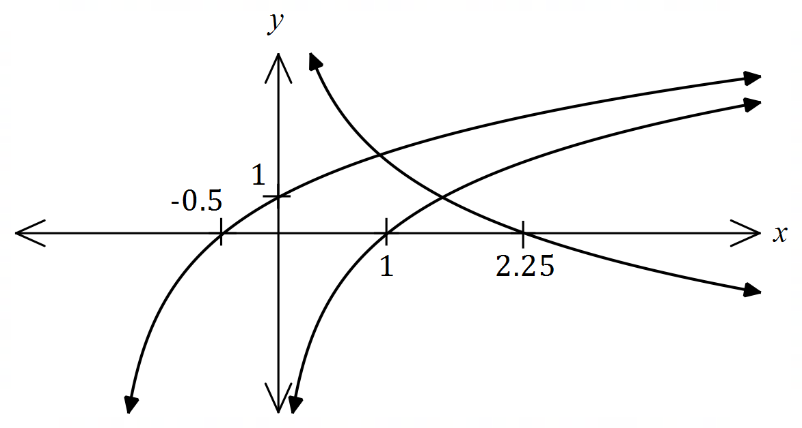

|  |
| --- |
| **Solution** |
| $g\left(x\right)$ through $\left(1,0\right)$, $a-g(x)$ through $(2.25,0)$, $g(x+b)$ has $2$ intercepts.  Using $(-0.5, 0)$: $\log_{n}\left(-0.5+b\right)=0⇒b=1.5$ Using $(0, 1)$: $\log_{n}{(0+1.5)}=1⇒n=1.5$ Using $(2.25, 0)$: $a-\log_{1.5}\left(2.25\right)=0⇒a=2$ |
| **Specific behaviours** |
| ✓ matches transformations to graphs  ü value of $a$; ü value of $b$; ü value of $n$ |

Question 11 (7 marks)

In a sample of $1 325$ university students, $64\%$ said that they never look at their phone while driving.

(a) Show how to use the figures from this sample to construct the $95\%$ confidence interval for the proportion of university students who never look at their phone while driving. (3 marks)

|  |
| --- |
| **Solution** |
| The proportion given is $p=0.64$. $$s=\sqrt{\frac{0.64\left(1-0.64\right)}{1325}}=0.01319$$ Hence, the margin of error is: $$E=1.96×0.01319=0.0258$$ Hence $95\%$ confidence interval is $0.64±0.0258$: $$(0.614, 0.666)$$ |
| **Specific behaviours** |
| ✓ standard deviation of sample proportion  ü margin of error  ü correct interval to at least $3$ dp |

(b) According to a newspaper article, " $70\%$ of university students never look at their phone while driving". Explain whether the interval from (a) supports this claim. (2 marks)

|  |
| --- |
| **Solution** |
| Interval does not support this claim, as the claimed proportion of $0.7$ does not lie within the interval. |
| **Specific behaviours** |
| ✓ states claim not supported  ü states interval does not include claimed proportion |

(c) Another source claims that "the majority of university students never look at their phone while driving". Explain whether the interval from (a) supports this claim. (2 marks)

|  |
| --- |
| **Solution** |
| Interval does support this claim, as the majority means more than $0.5$ and both bounds of the interval exceed $0.5$. |
| **Specific behaviours** |
| ✓ states claim supported  ü states bounds of interval exceed $0.5$ |

Question 12 (6 marks)

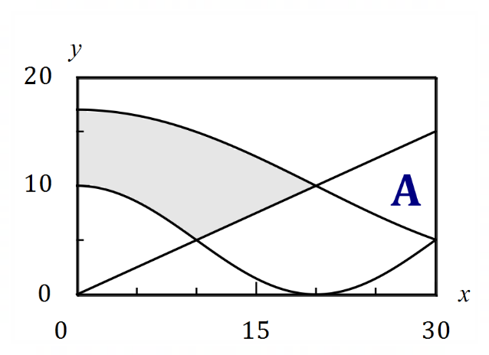The diagram shows a flag design,  
with dimensions in centimetres.

The shaded region is bounded by  
the $y$-axis, $y=f\left(x\right)$, $y=g(x)$  
and $y=h(x)$ where $f(x)=0.5x$ 
  
, $g(x)=5+5\cos\left(\begin{matrix}πx \\ \overline{20}\end{matrix}\right)$ 
  
 and $h(x)=10+7\sin\left(\begin{matrix}π(x+20) \\ \overline{ 40 }\end{matrix}\right)$ 
  
.

(a) Let $A$ be the area of another region on the graph, where $A=\int_{20}^{30}{\underset{ }{\overset{ }{\left[f(x)-h(x)\right]}}}dx$.

(i) Clearly mark the region on the diagram with the letter $A$. (1 mark)

(ii) Determine the value of $A$, rounded to one decimal place. (1 mark)

|  |
| --- |
| **Solution** |
| $$A=51.1 {\text{cm}}^{2}$$ |
| **Specific behaviours** |
| ✓ correctly marks $A$; ü correct area |

(b) Determine the exact area of the shaded region. (4 marks)

|  |
| --- |
| **Solution** |
| $$R_{1}=\int_{0}^{10}{\left[h\left(x\right)-g(x)\right]}dx \\ =\frac{140\sqrt{2}-100}{π}+50$$ $$R_{2}=\int_{10}^{20}{\left[h\left(x\right)-f(x)\right]}dx \\ =\frac{280-140\sqrt{2}}{π}+25$$ $$R_{1}+R_{2}=\frac{180}{π}+75 {\text{cm}}^{2}$$ N.B. $$R_{1}≈81.2, R_{2}≈51.1, R_{1}+R_{2}≈132.3$$ |
| **Specific behaviours** |
| ✓ writes one required integral  ü evaluates one integral exactly  ü writes both required integrals  ü correct exact area |

Question 13 (8 marks)

The weights of boys $W$ in a large study of $5$-year-old children are normally distributed with a mean of $18.2$ kg and a standard deviation of $2.15$ kg.

(a) Determine the probability that a randomly selected boy from the study has a weight

(i) that rounds to $17$ kg, to the nearest kilogram. (2 marks)

|  |
| --- |
| **Solution** |
| $$P\left(16.5<W<17.5\right)=0.1578$$ |
| **Specific behaviours** |
| ✓ indicates range of weights  ü correct probability |

(ii) no more than $20$ kg given that they weigh at least $18.2$ kg. (2 marks)

|  |
| --- |
| **Solution** |
|  |
| **Specific behaviours** |
| ✓ indicates use of conditional probability  ü correct probability |

(b) The heaviest $4\%$ of boys were classified as obese. Determine the least weight of a boy to be classified in this manner. (1 mark)

|  |
| --- |
| **Solution** |
| $$P\left(W>k\right)=0.04⇒k=21.96 \text{kg}$$ |
| **Specific behaviours** |
| ✓ correct weight |

(c) The weights of girls in the study are normally distributed with mean of $17.9$ kg and the heaviest $2\%$ of girls, weighing more than $22.5$ kg, were classified as obese. Determine the standard deviation of the girls' weights. (3 marks)

|  |
| --- |
| **Solution** |
| $$P\left(Z>z\right)=0.02⇒z=2.0537$$ $$\frac{22.5-17.9}{σ}=2.0537$$ $$σ=2.24 \text{kg}$$ |
| **Specific behaviours** |
| ✓ indicates use of $z$-score  ü forms equation for $σ$ ü correct standard deviation |

Question 14 (8 marks)

A cooling system maintains the temperature $T$ of an integrated circuit between $0.5 °C$ and $1 °C$. At any instant, $T$ is a continuous random variable defined by the probability density function

$$f\left(t\right)=\left\{ \begin{matrix}\frac{a}{t} & 0.5≤t≤1 \\ \overset{ }{0} & \text{elsewhere.}\end{matrix}\right.$$

(a) Determine the exact value of the constant $a$. (2 marks)

|  |
| --- |
| **Solution** |
| $$\int_{0.5}^{1}{\frac{a}{t}}dt=a\ln{2}$$ Integral must evaluate to $1$: $$a=\frac{1}{\ln{2}}$$ |
| **Specific behaviours** |
| ✓ integrates over interval  ü correct value of $a$ |

(b) Determine a decimal approximation for the probability that a temperature taken at random exceeds $0.85 °C$. (2 marks)

|  |
| --- |
| **Solution** |
| $$P\left(T>0.85\right)=\int_{0.85}^{1}{f(t)}dt \\ ≈0.2345$$ |
| **Specific behaviours** |
| ✓ indicates integral  ü correct probability |

(c) Determine decimal approximations for the mean and standard deviation of the temperature of the integrated circuit. (4 marks)

|  |
| --- |
| **Solution** |
| $$E\left(t\right)=\int_{0.5}^{1}{t×f\left(t\right)}dt \\ =\frac{1}{2\ln{2}}≈0.721 °C$$ $$\operatorname{Var}{(T)}=\int_{0.5}^{1}{{\left(t-\frac{1}{2\ln{2}}\right)}^{2}×f(t)}dt \\ ≈0.02067 \\ \text{sd}=\sqrt{0.02067}≈0.144 °C$$ |
| **Specific behaviours** |
| ✓ writes correct integral for mean  ü correct mean  ✓ writes correct integral for variance  ü correct standard deviation |

Question 15 (8 marks)

The voltage generated by a circuit at time $t$ seconds is given by $V(t)=e^{0.1t}\sin{(2t)}$ for $0≤t≤5$.

(a) Show that the voltage is initially increasing. (2 marks)

|  |
| --- |
| **Solution** |
| $$V'(t)=\frac{e^{0.1t}∙\sin{2t}+20e^{0.1t}∙\cos{2t}}{10} \\ V^{'}\left(0\right)=\left(0+20\right)÷10=2 \text{volts/s}$$ Since $V^{'}\left(0\right)>0$ then voltage is initially increasing. |
| **Specific behaviours** |
| ✓ indicates $V'(t)$ ü shows $V^{'}\left(0\right)>0$ |

(b) Using a graphical method, or otherwise, determine the voltage at the instant the rate of change of voltage first starts to decrease. (3 marks)

|  |
| --- |
| **Solution** |
| $V'(t)$ starts to decrease when $t≈0.04996$. $$\left[V^{''}\left(t\right)=\frac{-399e^{0.1t}∙\sin{2t}+40e^{0.1t}∙\cos{2t}}{100}⇒V^{''}\left(t\right)=0⇒t≈0.04996\right]$$ $$V\left(t_{1}\right)=0.1003 \text{volts}$$ |
| **Specific behaviours** |
| ✓ sketch of $V'(t)$ for small $t$ or obtains $V''(t)$ ü indicates first maximum of $V'(t)$ or solves $V^{''}\left(t\right)=0$ ü correct voltage |

(c) Use the increments formula to estimate the change in voltage in the one tenth of a second after $t=3$. (3 marks)

|  |
| --- |
| **Solution** |
| $$V^{'}\left(3\right)=2.554$$ $$δV≈\frac{dV}{dt}×δt \\ ≈2.554×0.1 \\ ≈0.255 \text{volts}$$ |
| **Specific behaviours** |
| ✓ uses increments formula  ü correct $V'(3)$ ü correct estimate |

Question 16 (10 marks)

Random samples of $165$ people are taken from a large population. It is known that $8\%$ of the population have blue eyes.

(a) Use a discrete probability distribution to determine the probability that the proportion of people in one sample who have blue eyes is less than $7\%$. (3 marks)

|  |
| --- |
| **Solution** |
| $$X\sim B\left(165, 0.08\right)$$ $$n≤\left\lfloor 0.07×165\right\rfloor =\left\lfloor 11.55\right\rfloor =11$$ $$P\left(X≤11\right)=0.3241$$ |
| **Specific behaviours** |
| ü indicates binomial distribution  ✓ indicates $n$ for $p<0.07$ ü correct probability |

(b) Ten consecutive random samples are taken. Determine the probability that the proportion of those with blue eyes is less than $7\%$ in exactly half of these samples. (2 marks)

|  |
| --- |
| **Solution** |
| $$Y\sim B\left(10, 0.3241\right)$$ $$P\left(Y=5\right)=0.1271$$ |
| **Specific behaviours** |
| ✓ defines binomial distribution  ü correct probability |

A large number of random samples of $165$ people are taken, the proportion of blue eyed people calculated for each sample and the distribution of these sample proportions analysed.

(c) Describe the continuous probability distribution that these sample proportions approximate, including any parameters. (3 marks)

|  |
| --- |
| **Solution** |
| $$v=\frac{0.08×(1-0.08)}{165}≈0.000446 \\ s=\sqrt{v}≈0.02112$$ The sample proportions will approximate a normal distribution with mean of $0.08$ and variance of $0.000446$ (or standard deviation of $0.02112$). |
| **Specific behaviours** |
| ✓ indicates normal distribution  ü correct mean  ü correct variance (or standard deviation) |

(d) Describe how two factors affect the closeness of the approximate distribution in (c) to the true distribution of proportions. (2 marks)

|  |
| --- |
| **Solution** |
| A large sample size and a proportion near to $0.5$ will lead to closer approximate normality. |
| **Specific behaviours** |
| ✓ indicates large sample size  ü indicates $p$ close to $0.5$ |

Question 17 (8 marks)

A charged capacitor discharges through a resistor. Some readings of the deflection $D$ cm of a galvanometer scale in the circuit $t$ seconds after the discharge began are shown on the semilogarithmic graph below.

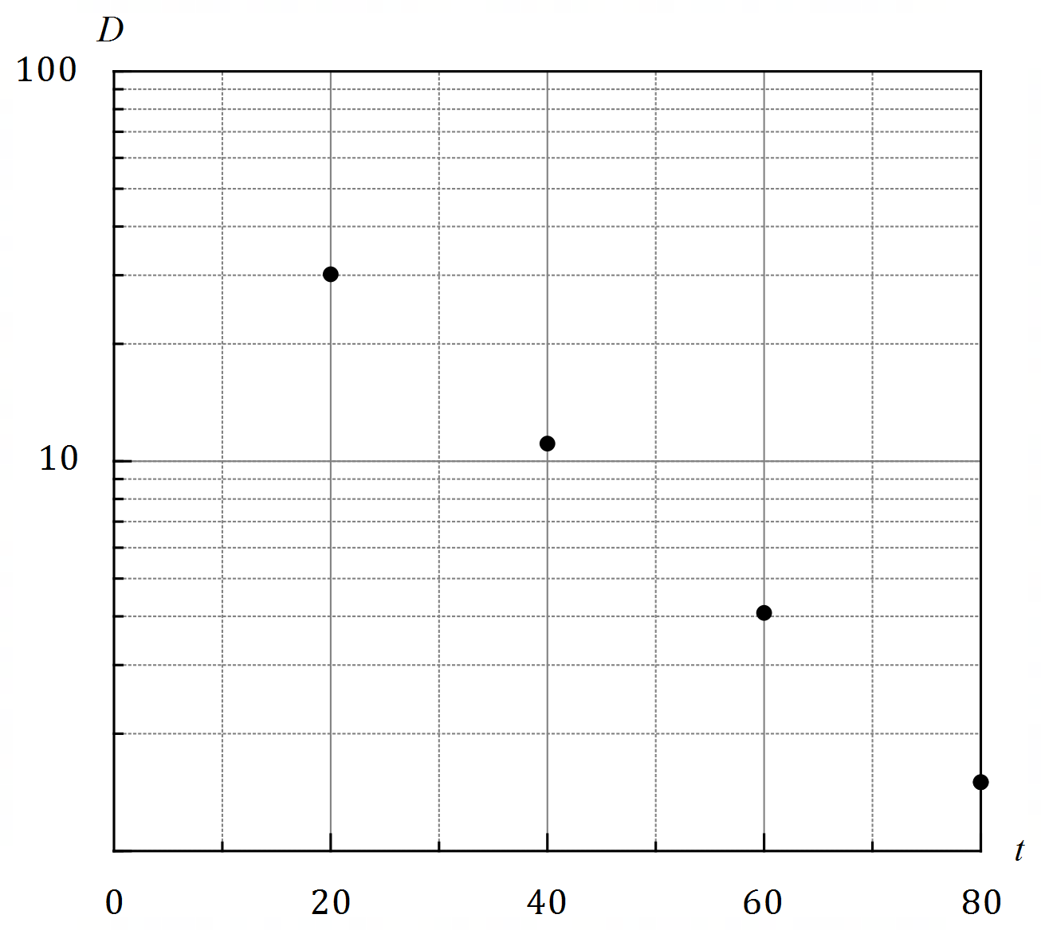

The relationship between the variables is of the form $D=ae^{kt}$, where $a$ and $k$ are constants.

(a) Use the above relationship to obtain an expression for $\ln{D}$ in terms of $a$, $k$ and $t$ and hence explain why plotting the data using a logarithmic scale on the vertical axis aligns the points in a straight line. (2 marks)

|  |
| --- |
| **Solution** |
| Taking logs: $$\ln{D}=\ln{ae^{kt}} \\ =\ln{a}+kt\ln{e} \\ \ln{D}=kt+\ln{a}$$ Hence the relationship between $\ln{D}$ and $t$ is linear. |
| **Specific behaviours** |
| ✓ uses natural logs  ü exposes linear relationship |

(b) Show how to use the relationship and the galvanometer readings at $t=20$ and $t=60$ to determine estimates for $a$ and $k$. (4 marks)

|  |
| --- |
| **Solution** |
| Reading points from graph: $(20, 30)$ and $(60, 4)$.  Using log relationship: $$\ln{4}=60k+\ln{a}$$ $$\ln{30}=20k+\ln{a}$$ Subtracting equations (or solving simultaneously with CAS): $$40k=\ln{4}-\ln{30} \\ k≈-0.05$$ $$\ln{a}=\ln{4}-60\left(-0.05\right) \\ a≈82$$ |
| **Specific behaviours** |
| ✓ correctly identifies both values of $D$ ü uses points to form equations  ü solves for $k$ ü solves for $a$ *NB accuracy ~ $2$ sf reasonable as reading data from graph* |

(c) Determine

(i) the deflection after $90$ seconds. (1 mark)

|  |
| --- |
| **Solution** |
| $$D=82e^{-0.05\left(90\right)} \\ ≈0.9 \text{cm}$$ |
| **Specific behaviours** |
| ✓ correct deflection |

(ii) the time for the deflection to reach $1$ mm. (1 mark)

|  |
| --- |
| **Solution** |
| $$0.1=82e^{-0.05\left(t\right)} \\ t≈134 \text{s}$$ |
| **Specific behaviours** |
| ✓ correct time |

Question 18 (8 marks)

Let $f\left(x\right)=1-{\left(x-3\right)}^{2}$ and $g\left(x\right)=\ln{(x-1)}$.

(a) Sketch the graphs of $y=f(x)$ and $y=g(x)$ for $x≥2$ on the axes below. (2 marks)

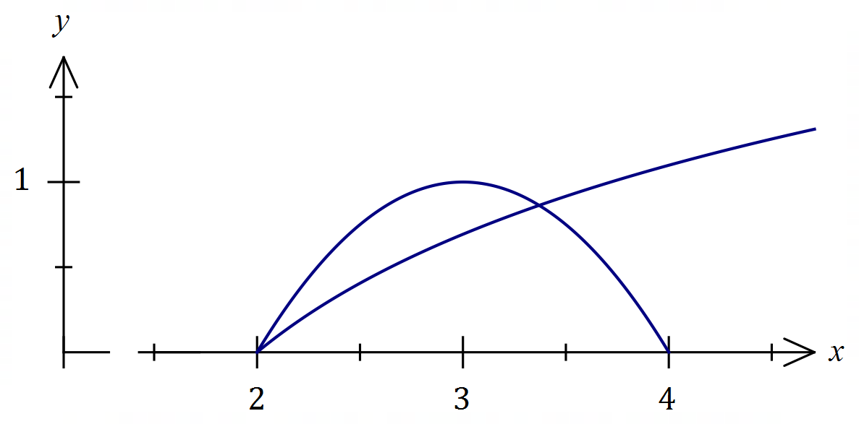

|  |
| --- |
| **Solution** |
| See graph |
| **Specific behaviours** |
| ✓  ü $y=g(x)$ |

(b) Show that $\begin{matrix}d \\ \overline{dx}\end{matrix}\left(\left(x-1\right)\ln\left(x-1\right)-\left(x-1\right)\right)=\ln\left(x-1\right)$. (2 marks)

|  |
| --- |
| **Solution** |
| $$\frac{d}{dx}\left(\left(x-1\right)\ln\left(x-1\right)-\left(x-1\right)\right)=1∙\ln\left(x-1\right)+\left(x-1\right)∙\frac{1}{x-1}-1 \\ =\ln\left(x-1\right)+1-1 \\ =\ln\left(x-1\right)$$ |
| **Specific behaviours** |
| ✓ uses product rule correctly  ü differentiates logarithmic term correctly |

(c) Show that the area of the region bounded by the graphs of $y=f\left(x\right)$ and $y=g\left(x\right)$, and the straight line $x=3$ is exactly $\frac{5}{3}-2\ln{2}$ square units. (4 marks)

|  |
| --- |
| **Solution** |
| $$A=\int_{2}^{3}{1-{\left(x-3\right)}^{2}-ln⁡(x-1)}dx \\ ={\left[x-\frac{1}{3}{\left(x-3\right)}^{3}-\left(\left(x-1\right)\ln\left(x-1\right)-(x-1)\right)\right]}_{2}^{3} \\ =\left[3-0-\left(2\ln{2}-2\right)\right]-\left[2+\frac{1}{3}-\left(0-1\right)\right] \\ =3-2\ln{2}+2-3-\frac{1}{3} \\ =\frac{5}{3}-2\ln{2}$$ |
| **Specific behaviours** |
| ✓ writes correct integral for area  ü antidifferentiates $f$ correctly  ü antidifferentiates $g$ correctly  ü substitutes correctly with clear simplification steps |

Question 19 (8 marks)

The cross section of a triangular prism with a volume of cm3 is an equilateral triangle of side length $x$ cm.

(a) Show that the surface area $S$ cm of the prism is given by $S=\begin{matrix}\sqrt{3}x^{2} \\ \overline{ 2 }\end{matrix}+\begin{matrix}1728\sqrt{3} \\ \overline{ x }\end{matrix}$. (4 marks)

|  |
| --- |
| **Solution** |
| Area of triangle: $$A=\frac{1}{2}x^{2}\sin{60°}=\frac{\sqrt{3}x^{2}}{4}$$ Volume of prism: $$Ah=432⇒h=432÷\frac{\sqrt{3}x^{2}}{4}=\frac{1728}{\sqrt{3}x^{2}}=\frac{1728\sqrt{3}}{3x^{2}}$$ Surface area of prism: $$S=2\left(\frac{\sqrt{3}x^{2}}{4}\right)+3\left(x×\frac{1728\sqrt{3}}{3x^{2}}\right) \\ =\frac{\sqrt{3}x^{2}}{2}+\frac{1728\sqrt{3}}{x}$$ |
| **Specific behaviours** |
| ✓ area of triangle in terms of $x$ ü uses volume of prism to express $h$ in terms of $x$ ü indicates surface area is $2$ triangles and $3$ rectangles  ü logical steps and clear explanation throughout |

(b) Use calculus to determine the minimum surface area of the triangular prism. (4 marks)

|  |
| --- |
| **Solution** |
| $$\frac{dS}{dx}=\sqrt{3}x-\frac{1728\sqrt{3}}{x^{2}}$$ $$\frac{dS}{dx}=0⇒x^{3}=1728⇒x=12$$ $$\frac{d^{2}S}{dx^{2}}=\sqrt{3}+\frac{3456\sqrt{3}}{x^{3}}=3\sqrt{3}>0 \text{when} x=12⇒\text{mininum}$$ $$S\left(12\right)=216\sqrt{3} (≈374)$$ Minimum surface area is cm2. |
| **Specific behaviours** |
| ✓ first derivative  ü equates to zero to obtain $x$ ü justifies stationary point is a minimum  ü states minimum surface area |

Question 20 (6 marks)

A student was set the task of determining the proportion of people in their suburb who use public transport at least once a week.

(a) Briefly discuss the main source of bias in each of the following sampling methods.

(i) The student randomly selects staff and students using school records. (1 mark)

|  |
| --- |
| **Solution** |
| Biased, as  - convenience sampling/selection bias  - favours those who attend/work at school  - etc, etc. |
| **Specific behaviours** |
| ✓ indicates one source/type of bias |

(ii) The student invites people to respond to their survey using an advert in the suburbs free local paper. (1 mark)

|  |
| --- |
| **Solution** |
| Biased, as  - volunteer sampling/selection bias  - people responding may not live in suburb  - etc, etc. |
| **Specific behaviours** |
| ✓ indicates one source/type of bias |

(b) The student noted that $36$ out of all those sampled said they used public transport at least once a week and went on to construct the confidence interval $\left(0.32, 0.58\right).$ Determine the level of confidence of this interval. (4 marks)

|  |
| --- |
| **Solution** |
| $$p=\frac{0.32+0.58}{2}=0.45$$ $$E=0.58-0.45=0.13$$ $$\frac{36}{n}=0.45⇒n=80$$ $$0.13=z\sqrt{\frac{0.45(1-0.45)}{80}} \\ z=2.337$$ $$P\left(-2.337<z<2.337\right)=0.9806$$ Hence level of confidence is $98\%$. |
| **Specific behaviours** |
| ✓ calculates proportion $p$, margin of error $E$ ü calculates sample size $n$ ü equation for $z$ score  ü level of confidence |

Question 21 (8 marks)

When a customer plays an online game of chance, a computer randomly picks one letter from those in the word LUCKY, another from those in the word BOIST, and a third from those in the word GAMER. For example, the computer might pick KSR, YBG, and so on. The customer can see the words but does not know the computer's picks and has to guess the letter it has chosen from each word. The random variable $X$ is the number of letters correctly guessed by a customer in one play of the game.

(a) Complete the table below to show the probability distribution of $X$. (3 marks)

|  |  |  |  |  |
| --- | --- | --- | --- | --- |
|  |  |  |  |  |
|  |  |  |  |  |

|  |
| --- |
| **Solution** |
| See table. $X\sim B(3, 0.2)$. $P\left(X=0\right)=0.512$, etc. |
| **Specific behaviours** |
| ✓ indicates binomial distribution with parameters  ü one correct entry  ü all correct entries |

Each game costs a player $25$ cents. A player wins a prize of $\$14$ if they guess all three letters correctly, $\$1.40$ if they guess two out of three letters correctly but otherwise wins nothing.

(b) Determine $E(Y)$ and $\operatorname{Var}{(Y)}$, where the random variable $Y$ is the gain, in cents, made by the customer in one play of the game. (4 marks)

|  |
| --- |
| **Solution** |
| Possible values of $Y$ are $y=-25, 115, 1375$ $$P\left(Y=-25\right)=0.512+0.384=0.896 \\ P\left(Y=115\right)=0.096 \\ P\left(Y=1375\right)=0.008$$ Hence $$E\left(Y\right)=-0.36 \text{c}$$ $$\operatorname{Var}\left(Y\right)=16 954 {\text{c}}^{2}$$ |
| **Specific behaviours** |
| ✓ correct values for $y$ ü indicates distribution of $Y$ ü correct mean  ü correct variance |

(c) If an average of $250$ people from around the world play the game once every $20$ seconds, calculate the gross profit expected by the game owners in any $24$-hour period. (1 mark)

|  |
| --- |
| **Solution** |
| $$R=0.0036×250×3×60×24=\$3 888$$ |
| **Specific behaviours** |
| ✓ correct revenue in dollars |

Supplementary page

Question number: _________

Supplementary page

Question number: _________

© 2020 WA Exam Papers. Kennedy Baptist College has a non-exclusive licence to copy and communicate this document for non-commercial, educational use within the school. No other copying, communication or use is permitted without the express written permission of WA Exam Papers. SN245-165-4.